Install Git windows 10 :

Download the Git from official web site [git-scm.com,](https://git-scm.com/download/win) and download the latest version of Git.

For me, it is ***Git-2.16.1.4-bit.exe***version and follow the below simple steps to install git.

**Step 1 :**

Right click on downloaded Git file and run as administrator, then you can see the below information dialogue to go further installation.

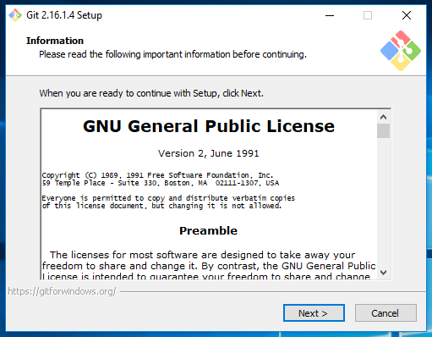

Read General Public Licence and click on Next>.

**Step 2:**

It will ask for Git installation directory by default it will be in ***C:\Program Files\Git***, you can change if you wish.

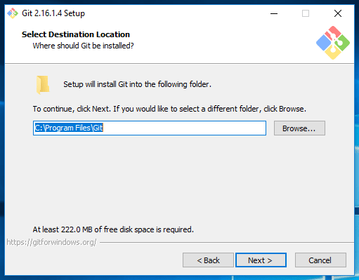

Click on Next>

**Step 3:**

This step allows you to select the git components which you want to install as part of the git installation.

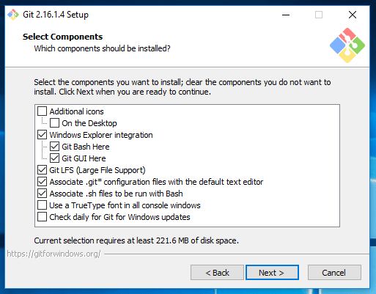

Above selection is recommended, those recommendations bring you Git GUI and Git Command prompt.

Click Next >

**Step 4:**

This dialogue asking you to create shortcuts of git, leave this as default and click Next >

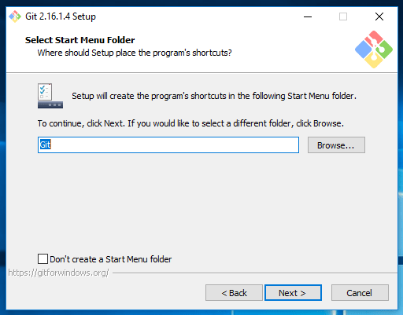

**Step 5 :**

Choose your favourite text editor to work with Git.

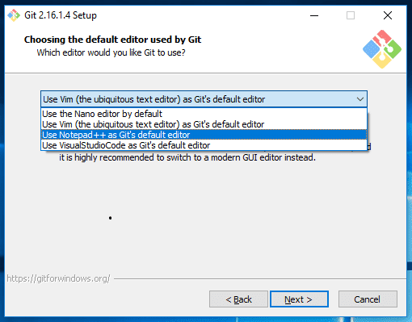

Click on Next >

**Step 6:**

This dialogue asking you to how do you want to use git to set the PATH, go with the recommended option.

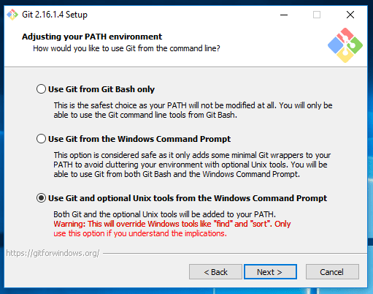

By choosing this step git automatically set PATH for you. I will show you how to see the generated PATH at the end of this article.

Click on Next >

**Step 7 :**

Choose for HTTPS transport, leave it as default.

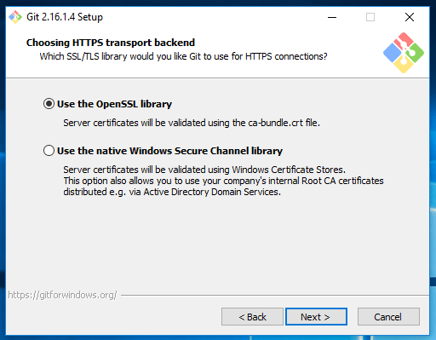

Click on Next >

**Step 8:**

Configuring the line ending conversions, leave it as default recommendation.

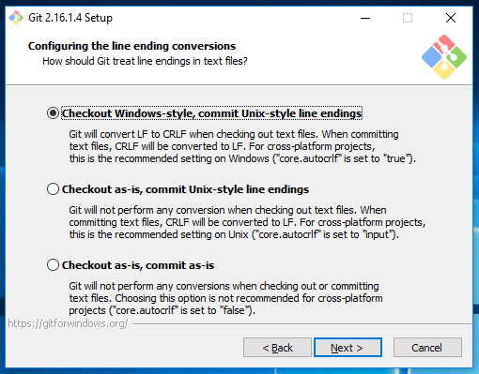

Click on Next>

**Step 9 :**

Choose for the terminal emulator to use Git Bash.

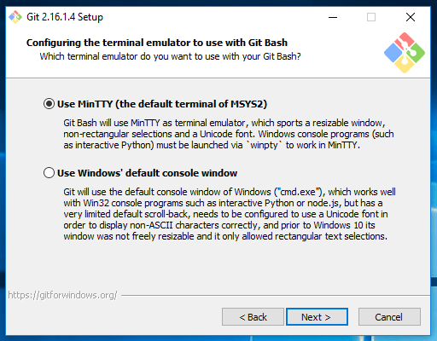

Click on Next >

**Step 10:**

This window allows you to enable extra features. Select the below recommendations.

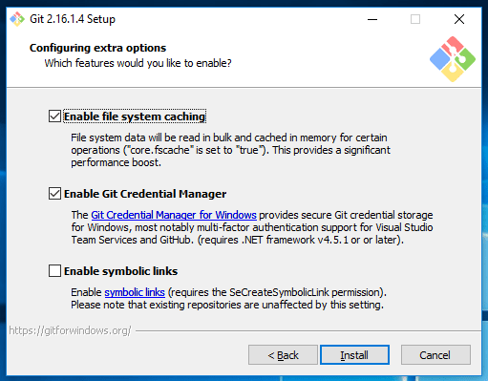

Click on Install

**Step 11 :**

Now started the installation process.

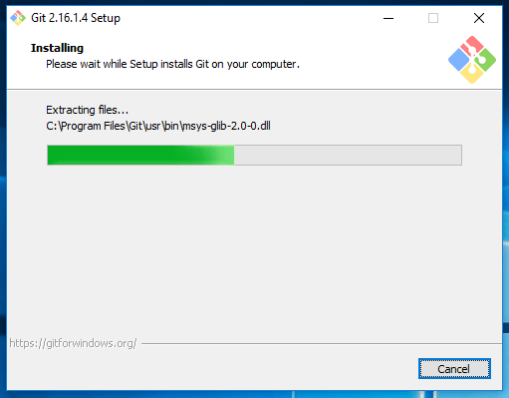

It will take a couple of minutes to complete.

**Step 12:**

If everything is done well, you can see the below information.

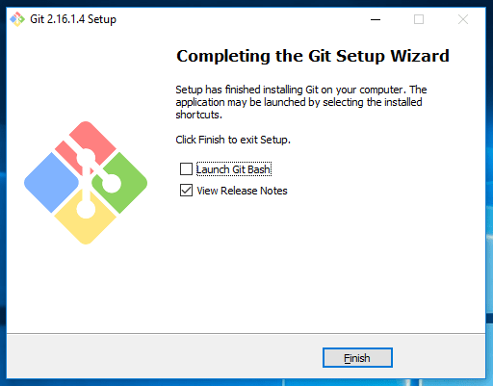Click on Finish.

Now you can install the Git on Windows 10 operating system.

**Check It :**

Check whether PATH has been set or not.

Advanced System Settings > Environment Variables > System Variables > select Path and click on Edit. You can see the below git paths.

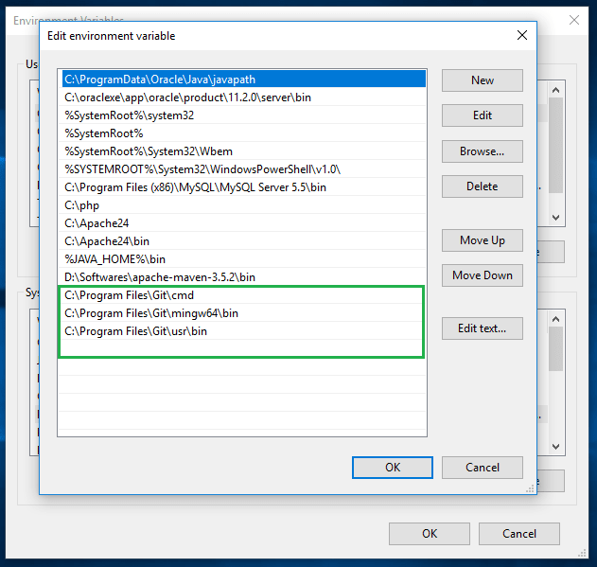

**Run it :**

Open command prompt and type git –version, you should see your installed git version like below.

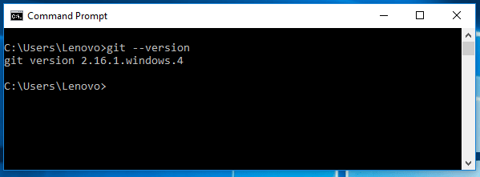

Now you can confirm that git has been installed successfully on your machine.